ACL TESTs
Show running Configurations
Router0
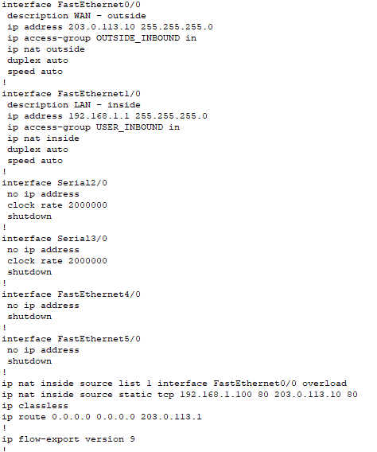

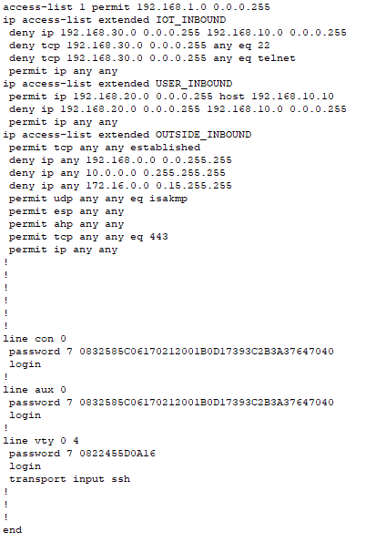
- Password changed from default
- Password encryption On
- Changed default gateway int fa0/0

Show access-list
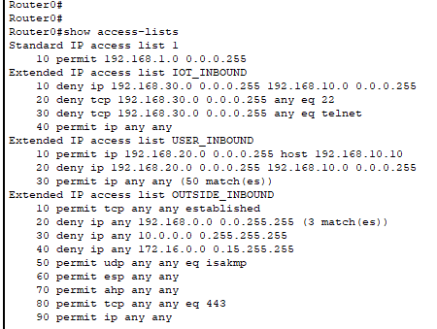

Switch0
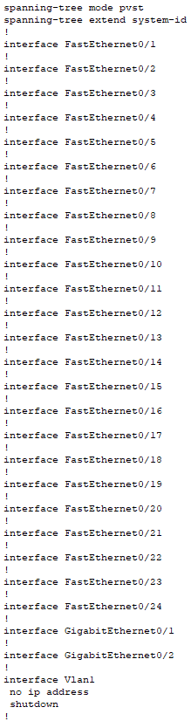
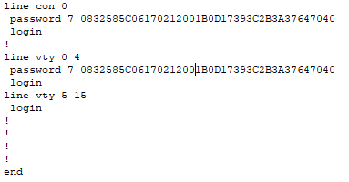
- Password on and encrypted

Test1 Outside Attacker

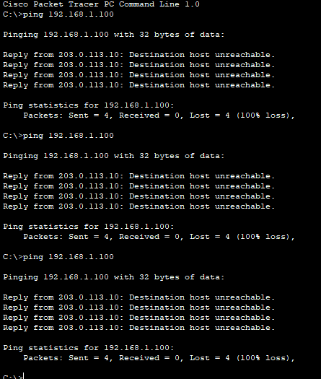
Ping from outside to dhcp status: failed
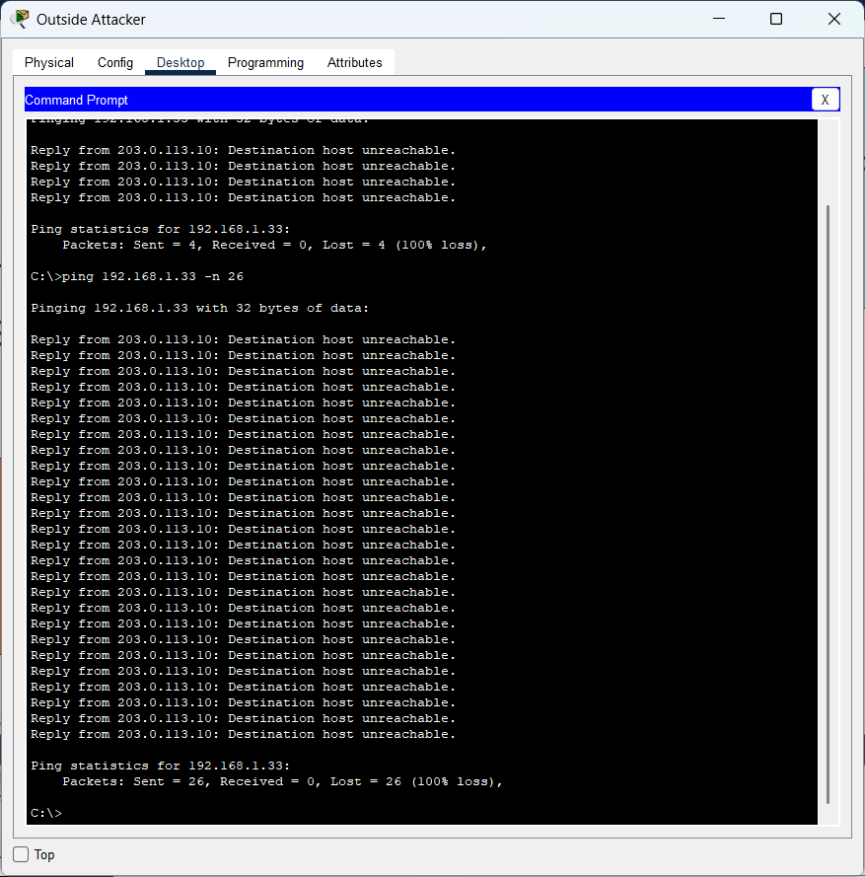

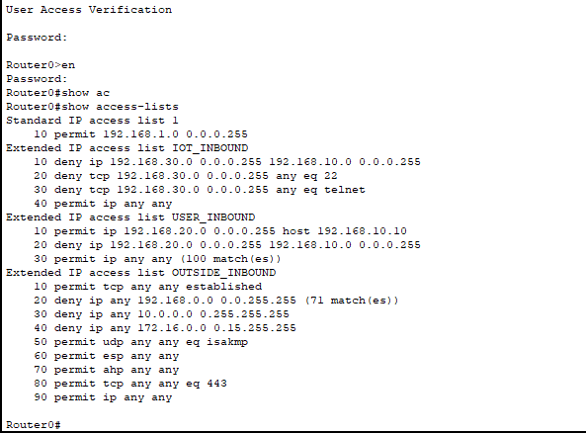
- Block traffic from outside into the internal network
- Ping failed ACLs working

Test 2 Internal Network
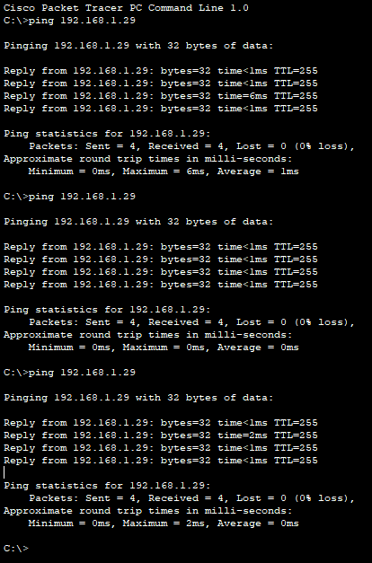
Ping from PC0(admin) to IoT3 Status: success
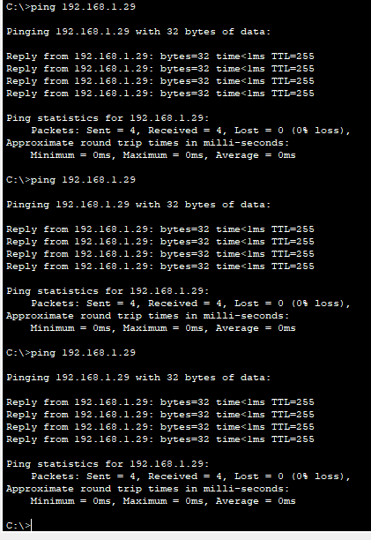
Ping from inside attacker to iot3 status:success

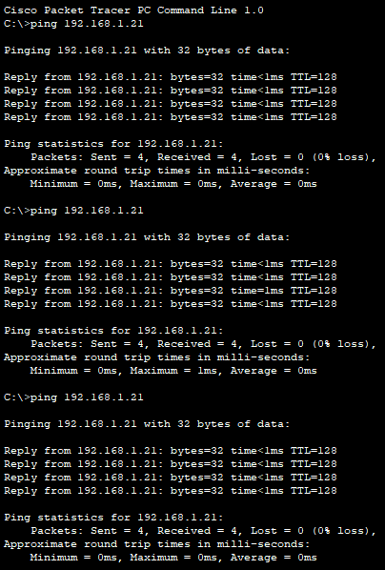
Ping from inside attacker to PC0(Admin) Status: success

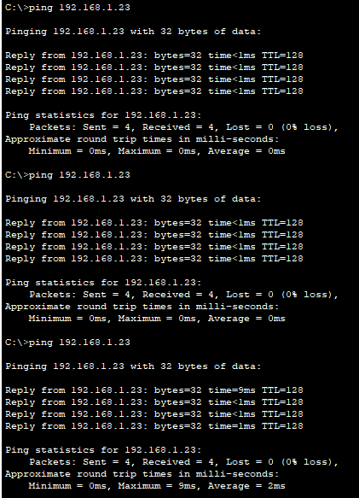
Ping from inside attacker to PC4 (management) Status: success
- Ping between department is successful
- Blocks outside traffic
- Blocks inside to outside traffic

